**CREATIVE EDUCATIONAL SERVICES**

**BEGINNING OF TERM I EXAMINATIONS 2024**

**PRIMARY TWO**

**SCIENCE**

**Name: ……………………………………………………………………**

**Stream…………………………………………………………………….**

1. Name one body building food.

____________________________________________________

1. We get ____________________ from a hen.
2. Why do we eat food?

We eat food to _____________________________

1. Which part of the body is used for seeing?

______________________________________________________

1. Draw a pencil
2. Draw and name one animal with two legs

|  |
| --- |
|  |
|  |

1. Write one energy giving food.

______________________________________________________

1. Give one animal that lives in the kennel.

______________________________________________________

1. Draw and name one non-living thing.

|  |
| --- |
|  |

1. __________________ is the first help given to a person who has got an accident. (First aid, Accident)
2. Name this need of a family.

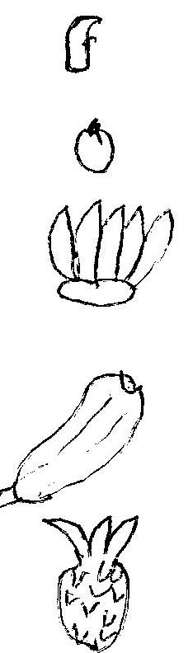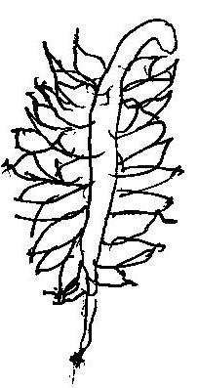

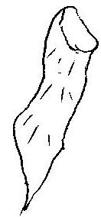

1. Which animal chases away rats?

_______________________________________________________

1. Write the body part you use to walk.

______________________________________________________

1. Draw this accident.

|  |
| --- |
|  |
| snake bite |

1. Name any food kept in bottle.

____________________________________________________

1. Which animal gives us milk?

____________________________________________________

1. Write one object that sinks in water?

_____________________________________________________

1. Draw an aeroplane

|  |
| --- |
|  |

1. Write one member of a nuclear family

______________________________________________________

1. Give one animal which lives in water

_______________________________________________________

**SECTION B**

1. Write any three common diseases.
2. ___________________________________________________
3. __________________________________________________
4. __________________________________________________
5. Give two killer diseases.
6. _________________________________________________
7. __________________________________________________
8. Mention three things that plants need to grow well.
9. _________________________________________________
10. _________________________________________________
11. _________________________________________________
12. Draw these family needs.

|  |  |  |  |
| --- | --- | --- | --- |
|  |  |  |  |
| food | clothes | water | house |

1. Underline the harmful insects

Mosquitoes white ants wasps

Cockroaches Grasshoppers

tsetseflies house flies

1. Name these non-living things.

|  |  |  |  |
| --- | --- | --- | --- |
|  |  |  |  |
|  |  |  |  |

1. Draw these things that move on wheels.

|  |  |  |  |
| --- | --- | --- | --- |
|  |  |  |  |
| a car | a bus | a bicycle | a lorry |

1. Tick ways of caring for plants.

pruning eating washing harvesting

weeding spraying watering

1. Write four living things.
2. ___________________________________________________
3. _________________________________________________
4. _________________________________________________
5. __________________________________________________
6. Give three names of food?
7. ___________________________________________________
8. _________________________________________________
9. _________________________________________________
10. Match animals with their meat.

pigs chicken

sheep beef

cows pork

hens mutton

1. Draw these things made by people.

|  |  |  |  |
| --- | --- | --- | --- |
|  |  |  |  |
| broom | dress | chalkboard | pencil |

1. Name the parts of the plant

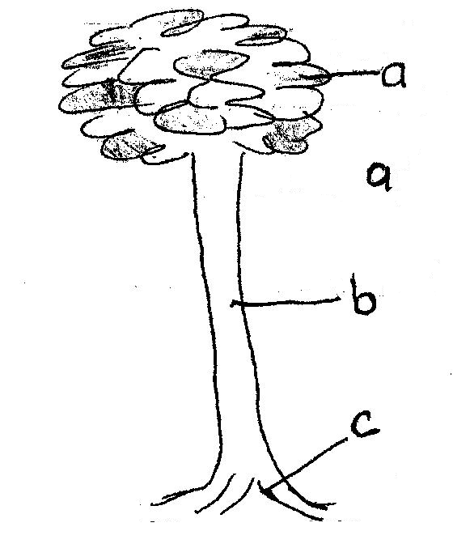

1. **Tick the uses of soil**

For making pots for drinking

For making bricks a home for some animals

For watering

1. Name the three types of soil
2. ___________________________________________________
3. _________________________________________________
4. __________________________________________________
5. Write one thing we get from clay soil.

______________________________________________________

1. Which type of soil is used for building?

It is _____________________ soil.

1. Tick what living things do.

Living things grow.

Living things feed.

Living things do not move.

Living things breathe.

Living things burn.

Living things move.

**END**